* Need to Launch VS as Admin???? NO
* Need to have permission to access following Projects (sf-source.citrite.net/projects/)
  + Platform
  + ShareFile
  + ShareFile Client
  + V3 Client SDKs
  + CLOUD (??? – NO need for this)
* Install GitExtension (or SourceTree)
* To get the source code -- go to the above project in web for example:

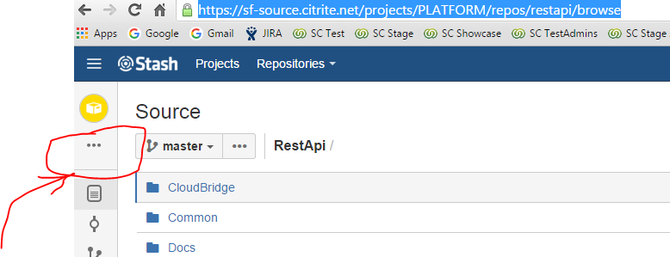

* Click the “…” then do “Clone”, pick either GitExtension or SourceTree

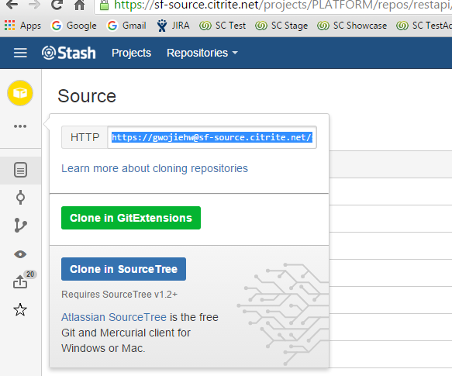

GJ Wang·10:04 AM

do you use Visual studio 2013 Community or Professional?

Shubhangi Priya·10:06 AM

I use professional

GJ Wang·11:35 AM

hi Shubhangi, running with 2013 professional, got a lot of compilation errors, I think it's a matter of a missing reference "Np", it cannot find Np.Database

GJ Wang·11:35 AM

[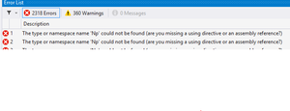](https://s3.amazonaws.com/uploads.hipchat.com/25280/3012520/iAvlnVhwTZ1utAd/upload.png)

[upload.png](https://s3.amazonaws.com/uploads.hipchat.com/25280/3012520/iAvlnVhwTZ1utAd/upload.png)15K

Shubhangi Priya·11:37 AM

on Manage Nuget Packages, there could be an option of 'Restore' if there are package errors

do you see such an option?

GJ Wang·11:41 AM

yeah, let me try it

GJ Wang·11:43 AM

[https://s3.amazonaws.com/uploads.hipchat.com/25280/3012520/ORGerRAnVRmIL3G/upload_thumb.png](https://s3.amazonaws.com/uploads.hipchat.com/25280/3012520/ORGerRAnVRmIL3G/upload.png)

[upload.png](https://s3.amazonaws.com/uploads.hipchat.com/25280/3012520/ORGerRAnVRmIL3G/upload.png)11K

got this error

Shubhangi Priya·Feb-8 4:22 PM

the first one can be ignored, I also get that

GJ Wang·Feb-8 4:22 PM

you mean the error?

Shubhangi Priya·Feb-8 4:22 PM

yes

Shubhangi Priya·11:48 AM

set the API Test project as a startup project  
build the project first, then the solution

also, verify that the source of ShareFile NuGet Server is <http://sf-nuget.citrite.net:81/nuget/ShareFile>

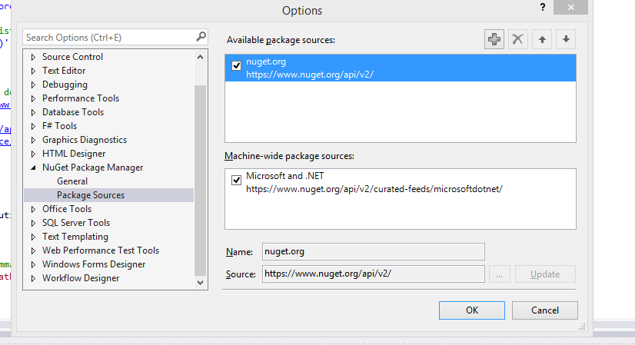

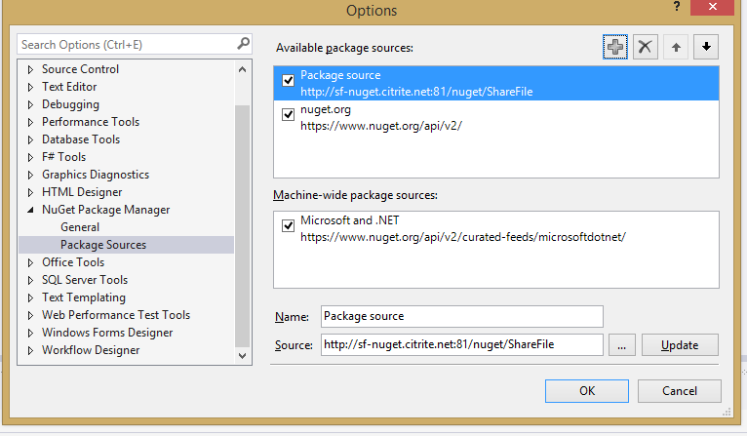

GJ Wang·12:14 PM

hmm... this is after I added the source, but still got same issue

GJ Wang·12:14 PM

[https://s3.amazonaws.com/uploads.hipchat.com/25280/3012520/NtEIeR4Z7DZzyU8/upload_thumb.png](https://s3.amazonaws.com/uploads.hipchat.com/25280/3012520/NtEIeR4Z7DZzyU8/upload.png)

[upload.png](https://s3.amazonaws.com/uploads.hipchat.com/25280/3012520/NtEIeR4Z7DZzyU8/upload.png)17K

Shubhangi Priya·12:17 PM

that's strange

GJ Wang·12:17 PM

hmm... wait

it does help a lot dropped from 2000+ errors to 2, this is all the errors I am getting now (compile api test first then the solution like you suggested)

GJ Wang·12:19 PM

[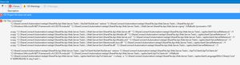](https://s3.amazonaws.com/uploads.hipchat.com/25280/3012520/yOoiUKlyAwHWDWq/upload.png)

[upload.png](https://s3.amazonaws.com/uploads.hipchat.com/25280/3012520/yOoiUKlyAwHWDWq/upload.png)63K

Shubhangi Priya·12:20 PM

in the configuration manager, is the tests project selected to build?

try cleaning the project and building it

Go to “Build” -> “Configuration Manager” -> check the “Web.server.tests”

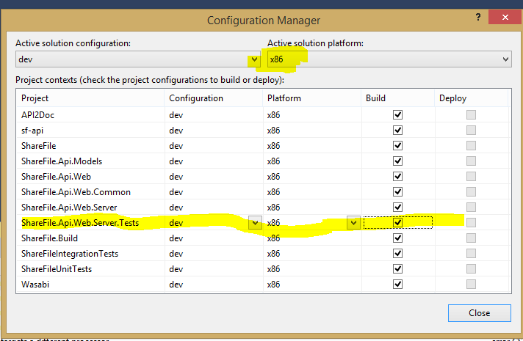

[upload.png](https://s3.amazonaws.com/uploads.hipchat.com/25280/3012520/SopGp27Z5w1FCK3/upload.png)34K

May NOT need do following:

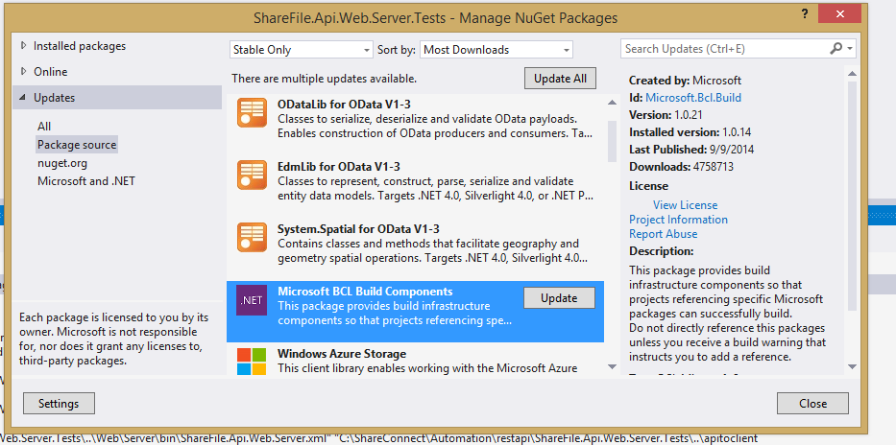

==========

In file APITestConfig.xml , need to change “account” which is the subdomain/release branch that you are testing again with –

<ShareFileAPITest>

<!-- Any of the setting are optional -->

<!-- Test url(s) are configured through /urls: command line parameters, or SF-ApiTestUrls environment variable.

The default value is ConfigReader.ApiTestUrl_Default.

-->

<APITestUrl>https://apiautomation111.sf-apitest.com</APITestUrl>

<!-- credentials of the account admin -->

=====================

Shubhangi Priya·Feb-4 1:31 PM

for running the tests

Right click on the test project, go to properties-> Debug window.  
In command line arguments, give: /run:ShareFile.Api.Web.Server.Tests.Items.HomeFolder(Admin).ItemsFileGet /exclude:KnownFailures,ConnectorTests,StorageZoneTests,Multitenant  
  
And then press cntrl+F5

it should execute the test mentioned if everything is fine

this is for running a single test

===========

you can also execute from command prompt by opening a cmd window from location where .exe of tests project is created and give the command ShareFile.Api.Web.Server.Tests.exe /exclude:KnownFailures,ConnectorTests,StorageZoneTests,Nightly,Notifications,DataIsolation

Use file C:\ShareConnect\Automation\restapi\ShareFile.Api.Web.Server.Tests\Connectors\CIFS\NetworkSharePaths.cs as example.

The items in /exclude: list can be found in the .cs files -- just search for

[Category("ConnectorTests")]

To run a single set (within a file) of tests

ShareFile.Api.Web.Server.Tests.exe /run:ShareFile.Api.Connector.Tests.CIFS

To run a single test case within a test file

ShareFile.Api.Web.Server.Tests.exe /run:ShareFile.Api.Connector.Tests.CIFS. AccessHiddenFoldersFilesAndCreateDuplicates

Under C:\ShareConnect\Automation\restapi\ShareFile.Api.Web.Server.Tests\bin\x86\dev\output

There are 2 files -- .txt and .xml

.xml file shows pass/faile cases.

.txt shows the API requests and responses.

Sharefile APIs documentation

http://api.sharefile.com/rest/docs/resource.aspx?name=ConnectorGroups